INTEGRATION OF GENERATIVE AI IN THE LEARNING ADVANCEMENT
OF COMPUTER STUDIES STUDENTS IN LYCEUM OF
SOUTHERN LUZON, INC.

A Research Study
Presented to the Faculty of
Lyceum of Southern Luzon, Inc.
Senior High School Department

In Partial Fulfillment of the Requirements for the
Information and Communications Technology Strand

By:
JHON ROY B. BRABANGCO
LEI JUSTINE B. LAYLAY
KIRSTEN ELMY S. CAMPOY
KHLOIE ASHLEY DIVINE D. REGENCIA
MYKA G. VILLAMOR

Co-author:
MA’AM DAERIEYLL M. CATIBOG

October 2025

APPROVAL SHEET
This study entitled “GENERATIVE AI IN THE LEARNING ADVANCEMENT OF COMPUTER STUDIES STUDENTS IN LYCEUM OF SOUTHERN LUZON, INC.” prepared and submitted by Brabangco, Jhon Roy B., Laylay, Lei Justine B., Campoy, Kirsten Elmy S., Regencia, Khloie Ashley Divine D., and Villamor, Myka G. has been approved and accepted as partial fulfillment of the requirements for the Information and Communications Technology Strand.

DAERIEYLL M. CATIBOG, LPT
Adviser

Accepted and approved in partial fulfillment of the requirements for the Information and Communications Technology by the Committee on Oral Examination.

PANEL OF EXAMINERS

MA’AM RAQUEL I. CERDENIA, MBA, LPT, CHRA, CFMP
Chairman

MRS. JAMAICA MARIBETH LAWI-CANOSA, LPT, CRS, CRDA, MAED
Member

MISS MA. JEE ANN C. BASTONA, LPT
Member

ACKNOWLEDGMENT
First of all, we would like to express our deepest gratitude to Our Heavenly Father for His continuous guidance, strength, and compassion throughout our study. Without His divine support, this research would not have been possible. He has served as our enduring source of strength and motivation, particularly in times of difficulty. We sincerely thank Him for His constant guidance and abundant blessings throughout this journey.
We would like to extend our sincere appreciation to our research teacher, Ma’am Daerieyll M. Catibog, LPT, for her invaluable time, patience, and insightful guidance throughout the course of this study. Her commitment and professionalism played a significant role in shaping and completing this research. We also wish to express our sincere gratitude to our defense panel members, particularly Ma’am Raquel I. Cerdenia, MBA, LPT, CHRA, CFMP, for their valuable insights and constructive suggestions that greatly improved the overall quality of our study. Their generosity in sharing their expertise and professional insights has been invaluable to the success of this research. In addition, we extend our heartfelt gratitude to Lyceum of Southern Luzon, Inc. for its unwavering support and for providing the essential resources that enabled us to complete this study.
We would also like to express our heartfelt gratitude for the moral support and encouragement from our classmates and fellow researchers, as well as the Computer Studies students of Lyceum of Southern Luzon, Inc., who participated in the study. We are equally thankful to our families for their unwavering faith, compassion, and belief in our abilities, which lifted our spirits and inspired us to complete this research.
-The Researchers

DEDICATION
We dedicate this study paper to our dearest research instructor, Ma'am Daerieyll M. Catibog, LPT. This study reflects her shining determination and perseverance to guide her students. Her guidance, has not only provided learning opportunities but also support as the researchers journeyed into this rocky road of academics and wits. We are also grateful towards Ma'am Raquel I. Cerdenia, MBA, LPT, for showing and sharing her experiences and advices, which significantly improved the quality of this paper.
This study is also dedicated to our peers and fellow student researchers, as we felt their high spirits and determination during this treacherous journey. During hard times we have all stayed close, worked hard together and laughed away the tears and frustration. Truly showing how teamwork can make the dream work.
Above all, we dedicate this research to the Almighty Creator of all, Father of all, God. As he is the ultimate source of strength, wisdom, and guidance, we give our thanks for providing those for this journey. We have felt his continuous blessings along the walk, equipping us with the power to keep pushing forward and persist through every curveball along our way.

-The Researchers

TABLE OF CONTENTS |  | Page
PRELIMINARY PAGES
TITLE PAGE |  | i
APPROVAL SHEET |  | ii
ACKNOWLEDGEMENT |  | iii
DEDICATION |  | iv
TABLE OF CONTENTS |  | v
LIST OF FIGURE |  | vii
ABSTRACT |  | viii
CHAPTER
I. INTRODUCTION
 | Background of the Study ……. | 1
 | Research Aim | 3
 | Statement of the Problem | 3
 | Theoretical Framework | 4
 | Conceptual Framework | 5
 | Research Paradigm | 5
 | Scope and Limitation of the Study | 6
 | Significance of the Study | 7
 | Definition of Terms | 7
 | Review of Related Literature and Studies | 10
 | Synthesis | 29
II. METHODOLOGY
 | Research Design | 34
 | Research Locale | 35
 | Participants of the Study | 35
 | Data Gathering Procedure | 36
 | Research Instrument | 36
 | Construction of Questionnaire | 36
 | Validation of Questionnaire | 37
 | Administration of Questionnaire | 37
 | Retrieval of Questionnaire | 38
 | Ethical Considerations | 38
III. RESULTS AND DISCUSSION
 | Findings | 40
 | Conclusions | 48
 | Recommendations | 50
BIBLIOGRAPHY |  | 51
REQUEST LETTER |  | 62
INTERVIEW QUESTIONS |  | 63
NARRATIVE REPORT |  | 65
DOCUMENTATION |  | 66
CURRICULUM VITAE |  | 67

LIST OF FIGURE
FIGURE NO. |  | TITLE
1  2 | Theoretical Framework………………………………………………..……...……4  Conceptual Framework…………………………………………………………….5

ABSTRACT
In this era of advancements, Generative Artificial Intelligence (GenAI) has gained traction for its capabilities, and many students have been utilizing it for their studies. In result, this study aims to examine how effective GenAI tools are in advancing computer studies, particularly in terms of how students can utilize it, how it can transform the learning process and how it changes the user’s views upon utilizing it. The researchers used an exploratory qualitative design to dissect student’s personal experiences, and insight about the role of GenAI in their learning. Additionally, this study used a framework called Generative AI-Enabled Sustainable Education (GAISE) (Baskara, 2024) to further support its exploration. The study used both purposive and volunteer sampling to select willing Bachelor of Science in Information Systems and Information and Communications Technology students who actively use GenAI in studies. The gathered data was done through both a written and online interview and had undergone a thematic analysis. The study concluded that GenAI tools can produce a more engaging and tailored content that can help visualize complex computer topics and provide alternative learning strategies, which helped many feel more confident in the learning process. Many also viewed AI as helpful and engaging, though some are wary on overdependency causing them to use it as means of guidance. The researchers recommended educators and educational institutions to consider integrating and teaching how to use GenAI tools and that future researchers should delve into how AI users can use AI videos and become more effectively aware of its nature of misinformation. Keywords: GenAI, Learning Advancement, Adaptive Personalization, AI Generated Content, Knowledge Construction,

Chapter I

INTRODUCTION
This chapter presents the background of the study, research aim, statement of the problem, theoretical framework, conceptual framework, related literature and studies, synthesis, and definition of terms.

Background of the Study
In this era of technological advancements, Artificial Intelligence (AI) has gain lots of traction for its mind-blowing capabilities to replicate human intelligence and complete simple tasks like writing papers, provide answers for difficult questions, create other forms of content etc. With recent advancements in machine learning, particularly in optimization and deep learning techniques, it has contributed to significant innovations in digital content generation, including the development of generative artificial intelligence (GenAI) (Hu, 2022).
By far, ChatGPT is one of the most famous types of GenAI applications but not limited to just it. GenAI systems are based on large language models (LLMs) which are a category of deep learning models trained on immense amounts of data, making them capable of understanding and generating natural language and other types of contents (Stryker, 2025). Currently there are Text-based LLMs, designed for natural language generation, translation, summarization, and conversational tasks. Code-generating LLMs specialized in programming tasks, offering real-time code suggestions, debugging, and explanation features. While Multimodal LLMs process inputs across formats such as text, images, and audio. There are also Instruction-tuned LLMs, optimized to follow user instructions more effectively, making them suitable for education, research, and productivity tools.
Since these types of GenAI tools can be easily accessed by anyone with a phone and internet connection, it has gain popularity among students. Based on the initial interview of the researchers, majority of the ICT and IS students in Lyceum in Southern Luzon, Inc, use ChatGPT, Meta AI and Cici. While minority uses Grammarly, Quill Bot, Perplexity and Gemini. Wherein they use it for a wide range of use, such as clarifying lessons, concepts and math formulas, while some utilize it as a grammar and code checker. This proves that AI is already being utilized for homework and educational purposes, however it creates more question than answers. To truly make education meaningful and real, education is meant to elevate student’s consciousness to evolve. Education is meant to helps individuals reach a higher state of being (Greenfield Chennai International School [GCIS], 2025) which signifies that it should reach advancement.
The increasing integration of Generative Artificial Intelligence (GenAI) in education raises significant considerations regarding its effectiveness in advancing learning. In the context of education, advancing refers to the process of promoting progress and improvement in students’ academic growth (Collins Dictionary, n.d.). Thus, GenAI may play a crucial role in enhancing the learning process and fostering student development, particularly in the field of computer studies. However, its actual effectiveness remains uncertain. This circumstance has prompted the researchers to investigate how GenAI can specifically support, enhance, and transform the learning experiences of computer studies students, who are inherently more familiar with the nature of innovative technologies.
Research Aim
Primarily, the purpose of this study is to explore how effective GenAI can support the learning process of Information System (IS) college and Grade 11 Information Communication Technology (ICT) students at Lyceum of Southern Luzon, Inc. Moreover, this study also aimed to examine various aspects of Generative Artificial Intelligence in education by exploring the components of Generative AI-Enabled Sustainable Education (GAISE) (Baskara, 2024): AI-Enhanced Content Generation, Adaptive Personalization, Interactive Knowledge Construction and Reflective Transformation. The purpose of the researchers is to uncover transformative ways to learn in the modern educational landscape. To be able to sustain education in this era of AI, it is crucial to explore the learner’s experience in using GenAI in supporting their learning process and practices.

Statement of the Problem
This study focused on the Role of Generative AI in the Learning Advancement of Computer Studies Students in Lyceum of Southern Luzon, Inc. It strived to provide certain responses to the following questions:
1. How do Computer Studies students find AI-generated educational materials useful in their studies?
2. What are the student’s experiences with generative AI in terms of adaptive personalize learning support in computer studies?
3. In what ways do students use generative AI tools to interactively construct their knowledge in programming?

4. How does the use of AI tools influence students' reflective transformation of AI's effectiveness in education

5. Based on the findings of the study, what output may be proposed?
Theoretical Framework
Generative AI-Enabled Sustainable Education (GAISE) (Baskara, 2024)
Primarily, Baskara (2024) explores the role of generative artificial intelligence as a driver of sustainable education. It emphasizes how GenAI can support learner-centered and future-oriented approaches by drawing on theoretical foundations such as constructivism, connectivism, and transformative learning. The framework highlights the potential of AI to promote inclusive access, personalized instruction, and critical engagement, positioning it as a catalyst for educational innovation and long-term development. In line with the theoretical perspectives and future directions outlined in the framework, Baskara (2024) recommended that generative AI be positioned not just as a technological tool, but as a transformative enabler of sustainable education.
This connects directly to this study, as it also aims to explore how genAI can transform and the learning process and push and sustain computer students’ progress. With the integration of the four components presented by Baskara (2024), can further aid the researchers dissect on how exactly it can create that transformation. With AI-Enhanced Content Generation, the researchers will explore the effectivity of turning AI-generated content into learning materials. For adaptive personalization, the researchers can ask the student’s experience on how GenAI tools it can solve certain learning problems and fulfill their requirements for effective learning. Using Interactive Knowledge Construction, the researchers will also explore how GenAI tools can promote active learning and aid in comprehending programming lessons, by using resources that are provided by AI. Lastly, the researchers will also integrate reflective transformation in the study, wherein they will investigate on how using AI can change the user’s perspective and usage of AI.
Conceptual Framework
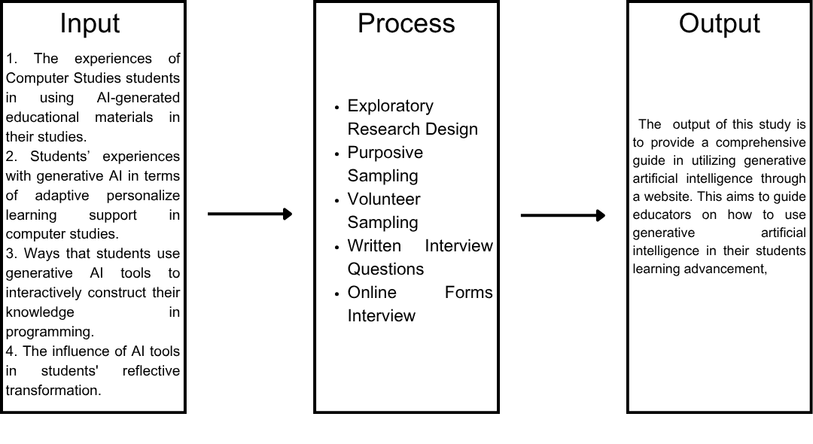Figure 1. Research Paradigm
For a better understanding of this study, the researchers provided the study's framework that establishes the study's perspective, which included a conceptual paradigm that got variables into consideration to show how this research will lead to a clear understanding of the ideas and variables presented.
This study aims to explore how GenAI has the potential to advance learning for computer studies students. The figure depicts the study's framework, which is based on the input-process-output (IPO) model. The IPO model has many interdisciplinary applications, beginning with the input of data that was processed and ending with the output going into the system of research methods.
The input box included the four variables in the GAISE theoretical framework, which are AI-enhance content generation, adaptive personalization, interactive knowledge construction and reflective transformation.
To analyze the result, the researchers picked the participants through a purposive and volunteer sampling and gathered the data with open-ended questionnaires. Written interviews were distributed to the chosen participants, and the data is thematically presented and interpreted as findings of the study. Based on the findings, the researchers created an exploratory study to provide insights on the effectiveness of GenAI in the learning advancement among computer studies students in Lyceum of Southern Luzon, inc.
Scope and Limitation of the Study
This study aimed to investigate the role of Generative Artificial Intelligence in the learning advancement of IS college and ICT students at Lyceum of Southern Luzon, Inc. Specifically, this study sought to explore how GenAI’s capabilities can support how computer studies students learn and advance their education through its aid. For the theoretical framework, this study acquired one of its recommendations, focusing on the effectiveness of different AI-driven pedagogical approaches in fostering transformative learning for sustainability (Baskara, 2024). This study is limited to Information System (IS) college and Information Communication Technology (ICT) students who use Generative Artificial Intelligence tools within Lyceum of Southern Luzon, Inc., Balayan, Batangas.

Significance of the Study
The researchers believed that the study has its own significance because it provides insights and benefits the following:

To the Information and Communications Technology (ICT) students and Information Systems (IS) students. This study showcases the potential of Generative AI to support learning programming education and practice. By harnessing the power of Generative AI, ICT and IS students can accelerate their learning, develop innovative solutions, and stay ahead in the rapidly evolving field of programming.
To the teachers. This study seeks to assist teachers in providing more flexible teaching strategies and promote the proper use of AI as an education assistant tool.
To the parents. This study aims to provide on how proper use generative AI can aid their children’s learning process at home.
To the school administrators. This study can provide further insights on how AI tools can transform education, and effectively integrate Artificial Intelligence in education, while promoting proper and responsible use.
To the future researchers. This study contributes to the growing body of knowledge on the application of GenAI in education. It can provide evidence on how GenAI can support the sustainability of education.

Definition of Terms
To facilitate the understanding of this study, different terms are defined herein:
Adaptive Personalization. Utilizing AI to tailor learning experiences to individual needs and learning styles within a sustainability context Baskara (2024). In this study, it refers on how AI can help adapt to computer studies students needs and personalized how they learn computer related topics.
Advancement. The coach-aided process of helping a learner take at least one positive step toward their goals (Insidetrack, 2024). In this study, this refers to how GenAI tools provide support in improving and progressing the learning process of Computer Studies.
AI-Enhanced Content Generation: Conceptually, leveraging AI to create diverse, up-to-date, and contextually relevant sustainability learning materials Baskara (2024). In this study, it signifies how AI generated content (videos, images, texts, and audios) can be useful in computer studies.
Artificial intelligence (AI). It pertains to technology that enables computers and machines to simulate human learning, comprehension, problem solving, decision making, creativity and autonomy (Stryker & Kavlakoglu, 2024). In this study, it refers to different kinds of generative AI that are found in student’s electronic devices and how they utilize it in their learning process.
Constructivism. A learning theory and a philosophy of education that suggests learners actively build their knowledge through experiences and interactions (McLeod, 2025). In this study, it refers to how Generative Artificial Intelligence can make the learning process more engaging and hands-on.
Connectivism. It accepts that technology is a major part of the learning process and that our constant connectedness gives us opportunities in learning (WGU, 2021). In this study, it refers to how using Generative Artificial Intelligence can provide more ways in advancing learning.
Generative AI. It is an unsupervised or semi-supervised machine learning for creating new content, including but not limited to digital images, video, audio, text, or code (Hu, 2022). In this study, it pertains to different kinds of AI applications that generates texts, videos, images, codes or audios that computer studies students utilize in their studies.
Interactive Knowledge Construction. Conceptually, it pertains to employing AI to facilitate constructivist and connectivist learning processes in sustainability education Baskara (2024). In this study, it refers on how AI provide interactive experiences for computer study students and help them to further utilize digital resources to further build and strengthen their knowledge and understandings of lessons.
Large language models (LLMs). This signifies a category of deep learning models trained on immense amounts of data (Stryker, 2025). In this study, it pertains to the type of GenAI applications computer studies students use.
Machine learning. A subset of AI focused on algorithms that can “learn” the patterns of training data and, subsequently, make accurate inferences about new data (IBM, n.d). In this study, it pertains to how generative AI works and help student’s inquiries.
Reflective Transformation. Using AI to support critical reflection and perspective transformation in sustainability learning Baskara (2024). In this study, it refers how use AI it pushes them to transform their perspective on AI and reflect of its benefits and harm.
Transformative learning theory. Focuses on the idea that learners can adjust their thinking based on new information (WGU, 2021). In this study, it focuses on how Generative AI usage pushes to reflect and create their own perspectives.
Review of Related Literature and Studies
AI-Enhanced Content Generation. GenAI is commonly known for its ability to generate all kinds of content, as a result this segment aims to explore similar literatures and studies about AI generated content in the context of utilizing it in educational purposes.
According to Tang and Zhao (2024), GenAIs like ChatGPT or AI that creates medias, can help teachers save time, reduce workload, and make it easier to create customized lessons, summaries, quizzes, and medias for students with different learning needs (Tang & Zhao, 2024). But they also warned that AI can sometimes make mistakes, show bias, or be too repetitive if not properly checked by teachers and school. They suggest that AI training should use diverse data and make sure it is properly integrated with learning systems. (Tang & Zhao, 2024).
Similarly, Mohamed et al. (2024) investigated how AI-powered language learning aids impacts students’ intrinsic motivation and learning experience. They argue that motivation is a key element of the learning process and to increase students’ intrinsic motivation to learn and enhance their academic achievement, educators should increasingly utilize interactive educational approaches. In result they found that AI’s ability to enhance learning experiences, autonomy, and critical thinking skills might boost in intrinsic motivation.
Furthermore, Mittal et al., (2024) looked at how AI’s ability to create dynamic learning content can be used in education. Things such as creating personalized lessons for each student, makes it easier for teachers to save time in preparing exercises, summaries, and full lesson plans., and offering students a more fun, fast and personal learning experience, adjusting the content based on their level, interests, or pace. However, the authors warned that AI systems might make mistakes, use biased data, or collect personal information without proper care. Suggesting that teachers and schools still need to double-check the AI’s work and utilize it responsibly.
Yadav (2024) argued that GenAI shows promise in supporting educators by automating the creation of learning resources and allowing them to focus more on interactive teaching and critical reflection. However, she discussed the risk of algorithmic bias in AI-generated content, concerns about informational accuracy, and the widening digital divide that may disadvantage students lacking access to modern technologies. To mitigate these challenges, she emphasizes the importance of teacher oversight, institutional policies, and AI literacy for both educators and learners.
As stated by Diwan et al. (2023), they demonstrate that AI-generated narratives can guide learners through content transitions, activate reflection, and reinforce comprehension. The findings indicate that the narrative fragments generated by their system were comparable in quality to human-written content. Furthermore, human evaluators reported that the fragments improved the flow and clarity of the learning sequence. Presenting a meaningful advancement in AI-enhanced education, showing that generative systems can move beyond static content delivery toward more personalized and dynamic learning experiences.
While Bozkurt (2023) suggests that AI is a great tool, but it needs to be used wisely and with human guidance. Teachers and students should work with AI, not let it do everything on its own. The goal is to make education more open and accessible for everyone, while still making sure the content is correct, fair, and shared responsibly.
Moreover, AI like ChatGPT can help create personalized learning materials for students. The results showed that students who used the AI-made materials often did better on their tests. They also seemed more engaged and interested in the topic. However, not every student had the same benefit, it heavily depends on how interested they were in the subject or how much they already knew. Teachers and developers who were interviewed also had mixed feelings: they liked the idea of using AI to support learning, but they were cautious about the accuracy of the content and whether it was always helpful (Binhammad et al., 2024).
Primarily, Maity and Deroy (2024) described how AI tools can create custom lessons, practice tests, and even step-by-step feedbacks, which where it slows things down and explains clearly, basing it on how well a student is doing. Providing students a more personalized learning experience. Additionally, the authors point out that AI can make mistakes and that it remains unclear if AI can work the same for everyone. The authors believe that if used carefully, AI tutors could become a powerful part of education in the future, especially if we keep improving how they work and make sure they’re used responsibly.
Additionally, Olusegun (2024) discussed how new AI tools that can generate educational content might improve access for students in poor or remote regions and bridge gaps in shortages of teachers, textbooks, and schools through scalable technology. They note that it can produce lessons in different languages, offer virtual tutoring, and operate effectively over low-bandwidth connections. However, it opens new challenges: lack of reliable internet access and adequate digital devices. Additionally, it contains inaccurate, biased, and misaligned information. Olusegun (2024) suggested that AI should complement and not replace, stressing the importance of policies in using AI.
Accordingly, one key insights in integration of generative AI, specifically GPT-4, into educational environments to personalize student learning experiences, was that availability of character-based narratives such as AI acting as batman, significantly increased overall engagement. The AI-generated quizzes were especially valued for self-assessment purposes, and students with initially lower performance levels showed measurable improvement after using the system. These outcomes suggest that generative AI can serve as a practical tool for differentiated learning, helping to close achievement gaps among students with varied academic abilities (Pesovski et al., 2024).
Furthermore, Faccia et al. (2023) examined the dual role of generative AI in supporting and complicating higher education content creation. The study highlighted the key advantages of generative AI, such as time-saving content production, scalability, and its adaptability to individual learning needs and pedagogical objectives. However, the paper also stressed risks, such as hallucinated outputs, plagiarism, diminished academic rigor, and reinforcing biases. Therefore, they suggested hybrid systems, where educators remain in control of reviewing, validating, and contextualizing AI-generated material, creating a responsible approach to technology integration in education.
Furthermore, Dickey and Bejarano (2024) argued that GenAI, when used responsibly, can reduce the time and effort required to produce diverse instructional assets such as readings, quizzes, and explanations. They propose a framework called GAIDE (Generative AI for Instructional Development and Education), which states that GenAI should enhance, not replace, the educator’s expertise, guiding teachers in developing effective prompts, refining AI-generated materials, and aligning content with learning outcomes. Results showed that instructors could generate relevant, adaptable materials while maintaining control over content accuracy and pedagogical alignment.
Congruently, the study by Guo et al. (2024) highlighted how generative AI platforms does not replace educators but can act as an intelligent assistant that enhances student engagement and adaptively respond to individual learning needs and bridge knowledge gaps by offering tailored content, interactive feedback, and dynamic simulations. Moreover, they enable students to construct knowledge through dialogue and exploration, aligning closely with constructivist principles such as social interaction, prior knowledge integration, and self-reflection.
Agbong‑Coates (2024) investigates the practical effects of integrating ChatGPT within classroom instruction. They describe that the use of ChatGPT as a facilitator for individualized learning: wherein students received personalized feedback, scaffolded explanations, and real-time support tailored to their skill levels. According to her findings, “students who regularly used ChatGPT for formative tasks demonstrated an average improvement in test scores and reported higher engagement and confidence” (Agbong‑Coates, 2024). This quote underscores the significant academic gains observed when AI tools are thoughtfully incorporated into pedagogy.
Adaptive Personalization. Students are complicated individuals with different requirements and learning styles, emphasizing the need for making the learning process more dynamic and personalized. For this section it aims to review similar studies and literature that explored on how AI can adapt and make learning much more personal.
Guettala et al. (2024) showed how generative AI tools, such as ChatGPT, can enhance the learning experience by making it more personalized and responsive to individual student needs. The research encourages thoughtful integration of generative AI into education systems to support more engaging, fair, and customized learning experiences and has the potential to act like a personal tutor. Despite these benefits, the study also identifies several concerns such as biased content, lack of transparency in AI decision-making, data privacy issues, and the challenge of training educators to effectively use these tools.
Furthermore, in Yilmaz & Yilmaz (2023)’s study, they explored the effect of using ChatGPT in programming education, specifically on students' computational thinking skills, programming self-efficacy, and motivation towards the lesson. Their findings revealed that students' who utilize ChatGPT had significantly higher computational thinking skills, programming self-efficacy, and motivation for the lesson compared to student who didn’t utilize ChatGPT on the lesson. They emphasized the potentiality of effectiveness of AI support in the lessons.
Kadaruddin (2023) asserted that “Generative AI allows educators to personalize learning experiences, create interactive content, and facilitate adaptive assessments, enhancing learner engagement and knowledge retention” However, it also addressed challenges such as data privacy, algorithmic bias, and the need for teacher mediation. Kadaruddin (2023) stresses that while GenAI offers substantial pedagogical benefits, its implementation must be guided by ethical frameworks and robust collaboration among educators, policymakers, and AI developers to ensure equitable and responsible use.
Additionally, Strielkowski et al. (2024) argued that GenAI-driven adaptive learning technologies promote personalized, accessible, and effective learning experiences—critical components for achieving Sustainable Development Goals in education. Additionally, they further asserted that such technologies do more than support learning efficiency. As they note: “adaptive learning technologies represented by innovative tools that personalize educational experiences…prepare more educated and informed citizens, drive innovation, and support economic growth necessary for achieving a sustainable future.” They suggested that adaptive AI systems, are primed to personalize education at scale, reduce dropout rates, and support lifelong learning pathways.
Whereas Mittal et al. (2024) explored a wide spectrum of generative tools from large language models (LLMs) like GPT to image and video generators, to the use of GAI in chatbots, virtual tutors, and automated assessment tools and highlight their ability to create dynamic learning content. These tools are shown to support adaptive learning by providing real-time feedback, simplifying grading processes, and supporting learners through interactive dialogue-based systems that suits individual needs, pace, and learning style, which has the potential to significantly enhance both teaching efficiency and student engagement. However, the authors also raise important ethical concerns, including data privacy, bias in outputs, misinformation, and over-reliance. The paper concludes by calling for responsible integration strategies that combine GAI with educational principles. Mittal et al. (2024) advocate for the development of regulatory policies, ethical guidelines, and teacher training to ensure that generative AI is used safely and equitably.
As highlighted by Baidoo-Anu and Ansah (2023), they examined the pedagogical opportunities and risks presented by ChatGPT in higher education. Their work, centers on how generative AI tools can support personalized, interactive, and autonomous learning environments when effectively integrated into the curriculum. They assert that tools like ChatGPT not only support students by offering instant feedback and generating examples but also assist teachers in instructional planning and formative assessment. Baidoo-Anu and Ansah (2023) ultimately advocate for a co-creative approach where educators and learners actively shape how generative AI is embedded in the classroom.
Primarily, Gligorea et al. (2023) found that AI are similar to smart digital tutors that can tailor lessons, quizzes, and study plans to fit each student’s learning pace and needs, increasing efficiency and effectivity. Some of the research even showed that students using adaptive learning systems performed better on tests and stayed more focused than those in traditional online classes. However, the paper also talks about privacy concerns and expenses. The authors recommend more research and development to make these tools easier to use, safer, and more accessible for teachers and schools. Overall, they believe AI has great potential to improve online learning if it’s used responsibly and with the right support.
Moreover, Maity and Deroy (2024) focused on Intelligent Tutoring Systems (ITS). The authors explain that GenAI can create fresh questions and better feedback based on how a student is doing in real-time. Making learning more personal and meaningful. However, one issue is that the AI might sometimes be inaccurate or biased; to fix this, the paper highlights the need for stronger rules around privacy and ethics as AI gets more involved in education.
A study by Guo et al. (2024) believed that learning is most effective when students build their own understanding through hands-on activities and experiences. With AI tools, students take more control of their learning, lessons and tasks can be adjusted to fit each student’s learning style, pace, and needs, making learning feel more engaging and meaningful. The authors recommend using AI in thoughtful and ethical ways, so it helps students grow and learn more effectively without taking away the important role of teachers.
Pesovski et al. (2024) explored how generative AI can revolutionize personalized learning by allowing students to select from multiple stylistic variants of instructional content, such as traditional academic tone or character-driven themes like Batman and Wednesday Addams. According to them, students found the multiple variants of the learning materials engaging … the most popular feature was the automatically generated quiz‑style tests. This insight underscored the appeal of diverse content formats and demonstrates that stylistic variation can increase both engagement and study time, particularly among learners who struggle with standardized materials. This emphasizes that the approach offers a promising pathway toward sustainable, student-centric learning design.
Furthermore, Bonde’s (2024) study argued that a conceptual layer of human-in-the-loop mechanisms, supported by explainable AI frameworks, is necessary to prevent misuse and bias. Although the article does not include implementation data, it provides a detailed technical and pedagogical roadmap. It describes modules for content generation, feedback adaptation, and interactive learner dashboards, all grounded in adaptive learning theory. Overall, Bonde (2024) offered a visionary yet grounded model that could guide future empirical research and system development. By weaving together AI capability, teacher agency, and ethical safeguards, he set the stage for a new wave of intelligent education tools.
Hatmanto et al. (2024) investigated how experienced teachers perceive and implement ChatGPT to support personalized learning experiences. They reported that teachers generally held a positive outlook toward ChatGPT’s ability to provide customized feedback, adapt to diverse learning preferences, and foster student autonomy. They also addressed notable concerns raised by teachers, including questions about cultural sensitivity, content reliability, and the potential for ChatGPT to reduce meaningful human interaction. To address these challenges, Hatmanto et al. stress the importance of providing professional development and contextual support to teachers integrating AI into existing pedagogical frameworks.
Additionally, Agbong-Coates (2024) examined the practical impact of integrating ChatGPT into classroom teaching. The study highlights ChatGPT’s role as a tool for personalized learning, providing students with tailored feedback, step-by-step explanations, and real-time assistance suited to their individual skill levels. Findings revealed that “students who regularly used ChatGPT for formative tasks demonstrated an average improvement in test scores and reported higher engagement and confidence” (Agbong-Coates, 2024). This emphasized the notable academic benefits that can result when AI technologies are strategically embedded in teaching practices.
Interactive Knowledge Construction. This domain focuses on how AI can support constructivism and promotes connectivism in studies.
Principally, Chen et al. (2023) explored how generative AI, specifically ChatGPT, can support knowledge-building activities among high school students. Their findings revealed that AI could help expand the range of student ideas and stimulate metacognitive awareness, especially when educators provided structured prompts. The paper emphasizes that AI is not treated as a simple information source but as a dialogic partner supporting deeper inquiry. However, the study also warns of overreliance, noting that without teacher guidance, some students used ChatGPT in superficial ways that undermined the knowledge-building process.
Hsu (2025) explores the pedagogical shift from traditional programming instruction to LLM-prompting as a means of cultivating computational thinking skills. Hsu (2025) observed that prompting LLMs encourages students to articulate computational problems more clearly, break tasks into modular components, and test solutions iteratively, core practices in computational thinking. As Hsu wrote, prompt engineering becomes an act of algorithmic design, requiring students to encode logic and constraints as they scaffold LLM responses (Hsu, 2025).
Cress and Kimmerle (2023) argued that while generative AI lacks true understanding, it can still serve as a stimulus for knowledge co-construction when used effectively. The key lies in prompting learners to move beyond passive content consumption into deeper engagement. As stated in the article, users need to establish a dialog that goes beyond knowledge telling… and stimulates knowledge transformation (Cress & Kimmerle, 2023). They proposed that AI-facilitated interactions can shift learners from passive or active modes to more constructive and interactive ones, provided that the AI is used strategically and reflectively within instructional design.
Moreover, Jayasinghe (2024) examined how ChatGPT can be used as a tool to foster active, constructivist learning. They report that students using ChatGPT to generate discussion prompts, simulate role plays, and draft argumentative essays showed increased engagement, critical reflection, and metacognitive awareness. Despite its advantages it has its challenges, including misinformation from AI-generated content, over-reliance on prompts, and disparities in access to digital resources. Jayasinghe (2024) advocates for instructor-mediated use, recommending that educators frame ChatGPT as a co-cognitive partner rather than an answer generator and incorporate digital literacy guidance into course design.
Congruently, Zhou and Schofield (2024) argued that AI can foster shared knowledge construction by supporting peer interactions, offering prompts for deeper thinking, and assisting with group coordination. The article suggested practical applications. These include designing scaffolded tasks where AI facilitates brainstorming, provides feedback, and prompts metacognitive reflection. The authors stress, however, that successful integration requires clear guidelines, teacher mediation, and an awareness of the ethical boundaries of AI use in education.
In addition, Grubaugh et al. (2023) stated that AI platforms such as ChatGPT, Bard, and Bing can support such pedagogy by providing adaptive, personalized, and interactive learning opportunities. They explained that constructivism emphasizes active, experiential learning grounded in personal and prior knowledge. Therefore, they highlight several advantages of AI-enhanced constructivism, including boosted student engagement, facilitation of self-reflective metacognition, and promotion of conceptual understanding. However, they emphasize that this integration must be balanced by preserving humanistic values, ensuring educators remain central as facilitators and ethical guardians.
In the study by Correia et al. (2024), the authors explore how AI can support modern approaches to teaching and learning, particularly through Rhizomatic Learning Theory (RLT) and Connectivist Learning Theory (CLT). These theories focus on interactive knowledge construction, emphasizing learner autonomy, decentralized learning environments, and the importance of collaboration in building knowledge. The study shows that while AI can enhance interactivity by personalizing learning and enabling real-time feedback, some areas, such as ethical concerns, data privacy, and the scalability of AI technologies, are not fully addressed by traditional learning theories. This indicates a need for updated pedagogical models that can better accommodate the unique capabilities and challenges of AI in education.
In a study by Santos (2023), the use of generative AI-powered chatbots such as ChatGPT, Bing Chat, and Bard, was explored in the context of physics learning. Their findings highlight how ChatGPT-4 promotes deep learning by engaging learners in reflective, dialogic, and Socratic-style interactions. Moreover, the research highlighted the importance of AI in stimulating critical thinking and active engagement, especially when used not merely as content providers but as co-participants in the learning process. However, it also acknowledges limitations, such as occasional factual errors and a lack of human empathy, emphasizing the continued need for human oversight in AI-assisted learning environments.
Similarly, Owen’s (2025) study emphasized how generative AI supports interactive knowledge construction by enabling learner-centered environments where students actively build understanding through exploration, collaboration, and reflection. The study underscores how AI tools can personalize learning, scaffold complex tasks, and promote creativity and agency among learners. However, the study cautions against over-reliance on AI and stresses the importance of ethical implementation, addressing concerns such as data privacy, bias, and equitable access.
In Bae and Bozkurt’s (2024) study, they examined whether GenAI promotes genuine knowledge construction or merely encourages personalization. While generative AI tools such as ChatGPT offer tailored scaffolding and adaptive learning paths, the study raises concerns about students’ over-reliance on AI-generated guidance, potentially weakening their independent thinking and problem-solving abilities. It also states that GenAI is designed to only support individual learning, as it may unintentionally reduce opportunities for peer interaction. However, the study acknowledges that if used thoughtfully, AI can enhance group inquiry, facilitate formative assessment, and support deeper engagement through immediate, context-aware feedback.
Additionally, the study by Salinas-Navarro et al. (2024) explores the integration of generative AI in experiential learning and authentic assessment. GenAI tools, such as ChatGPT and Bing, are shown to enhance interaction by enabling personalized learning, supporting higher-order thinking, and providing real-time, context-aware feedback. These AI tools function not just as content generators, but as agents that actively engage students in reflection, collaboration, and practical application. Through simulations, scenario-based tasks, and adaptive feedback systems, generative AI creates dynamic learning environments where students are co-constructors of knowledge.
Prestoza & Banatao (2024) examined how AI passion‑driven pedagogy (AI‑PDP) can enhance student engagement and academic success in Philippine classrooms. The study notes that “students reported feeling more motivated and invested in their learning when AI tools helped them pursue topics they care about.” Arguing that generative AI acts as a co-creative partner, enabling learners to explore, question, and create meaningful artifacts tied to their passions. The mixed-method approach reveals a nuanced understanding: while AI‑PDP boosts motivation and retention, teachers observed the need for scaffolding to prevent over-reliance on AI‑generated content and ensure academic rigor.
Reflective Transformation
This domain focuses on how an individual's perspective towards AI can transform and support the way users utilize AI technology in education. However, this requires deep reflection and full understanding of AI’s strengths and weaknesses in an educational context as well.
Primarily, Uğurlu (2024) analyzed how AI alters both instructional practices and the broader educational environment. He explains that AI can reduce dependency on traditional teacher-led instruction while enabling autonomous learning and free exploration of content. However, he warns of the risk that overreliance on AI may reduce interpersonal interaction, limit social-emotional learning, and introduce new forms of inequality. His analysis suggests that the educational sector must take a reflective, balanced approach, embrace technological innovation while maintain human-centered pedagogy and equity-focused strategies.
In Dewa’s (2025) study, it examined how AI can contribute to addressing educational disparities, improving learning outcomes, and aligning school systems with global sustainability goals, particularly Sustainable Development Goal 4. Dewa (2024) highlights that AI technologies such as adaptive learning systems, virtual tutors, and intelligent analytics platforms can be powerful tools in delivering equitable and personalized instruction. Dewa (2024) reports that even educators with high AI awareness showed minimal classroom implementation, suggesting that deeper systemic and institutional support is essential.
Furthermore, Lim et al.’s (2023) study asked if the raise of GenAI signals the beginning of a reformation or a potential collapse. The authors outline four core tensions educators face: AI as both a friend and foe, both capable and dependent, both accessible and restrictive, and simultaneously more popular when institutionally prohibited. Lim et al. (2023) argue that its impact depends on how educators confront and navigate its contradictions. As they write, “Generative AI is both a technological marvel and a pedagogical minefield—where opportunity and risk exist in equal measure” (Lim et al., 2023). The authors propose that the future of AI in education requires accepting and managing these contradictions.
Kumar and Sharma (2025) explored how secondary school teachers perceive the rapid expansion of GenAI in educational contexts. The study uncovers a nuanced balance between optimism for technological innovation and caution about its potential drawbacks. Despite instructional advantages, many teachers expressed fear that over-reliance on AI-generated content could undermine critical thinking and student ownership of learning. Additionally, privacy issues and uncontrolled usage remain pressing worries. Based on these insights, Kumar and Sharma (2025) propose a framework including a systematic professional development for teachers, ethical guidelines on AI usage, and curriculum-aligned integration strategies.
Moreover, Pikhart & Al-Obaydi’s (2025) study examined the concerns educators hold about AI in higher education settings. Participants reported worries about data privacy and academic integrity. While Educators expressed concerns that “they feared AI might facilitate plagiarism and undermine critical thinking” and the potential erosion of educators’ roles. Pikhart argued for the development of clear ethical guidelines and preservation of human-led pedagogy to guarantee that AI remains a tool rather than a determinant in educational ecosystems.
Aggarwal (2023) emphasized that AI-driven technologies not only improve efficiency in content creation but also support ecological consciousness in pedagogy. She writes, “AI can help create more sustainable development initiatives by allowing users to use fewer resources and more efficiently”. This reinforces the notion that the integration of AI into education has the potential to advance learning and environmental goals simultaneously. Overall, her contribution highlights an essential intersection of technology and sustainability in education. Her model serves as a strategic guide for policymakers and educators seeking to leverage AI for responsible, eco-conscious learning transformation.
The study of Novoa-Echaurren et al. (2025) focused on how the integration of AI has significantly reshaped teaching and learning experiences, creating new opportunities and challenges for educators. They argued that most frameworks that aim to assist educators in integrating digital technologies lack the educator’s reflection upon it. As a result, they discovered that social and collaborative configurations, such as receiving positive feedback from colleagues and students, helped push educators to actively consider and engage in applying artificial intelligence within educational contexts. In conclusion, reflective practices can help educators gain new insights and self-awareness towards their teaching, resulting in an AI open mindset, making the utilization and integration of AI much more uncomplicated.
In addition, Henriksen et al. (2024) highlighted that most traditional methods educators use in teaching have fallen short in properly preparing students to face changes in the digital world. They suggest that education must become much more creative to keep up with the ever-changing world, and they believe that AI has the potential to solve this problem. As a result, this study found that through AI’s capacity for data processing, pattern recognition, and generative capabilities, educators across various subjects can now truly innovate teaching and prepare students to learn and face the changes and challenges of today.
Meanwhile, in Artyukhov et al.’s (2024) study, it focused on the sustainability of higher education and students’ attitudes towards AI tools in education. As a result, Artyukhov et al. (2024) discovered that a minority of students do not fully see AI as a threat to higher education in 5 years, while others deem AI as a threat in 5 years. However, a majority of the student are not fully convinced but had a semi-concrete answer. The researchers concluded that they could not discuss whether AI can truly create a “safe” learning environment, due to their inability to pinpoint what kind of harm students think AI can bring. Highlighting the need to further explore students’ perceptions of AI and whether it can cause emotional or psychological damage.
Furthermore, Alamri et al. (2024) also concentrated on students’ perception towards GenAI in education. They claim that students’ perception of GenAI has yet to gain enough attention, and they argue that to be able to successfully integrate and use GenAI in education, the students’ perspectives and experiences must also be considered. Their findings reveal that in a student’s eyes, GenAI has become favorable for its capability to handle complex tasks, outweighing the risk it came with, which raises ethical concerns. They have also found that GenAI promoted engagement among students, encouraging them to learn independently and take initiative, making education more meaningful. However, Alamri et al. (2024) highlighted the fact that the reason why GenAI had a positive direction is that the chosen respondents were “digital natives.”
A study by Allam et al. (2025) prioritized the impact and challenges of integrating AI and living intelligence in higher education, concentrating on its advantages and limitations. As a result of their comprehensive analysis, they have found that living intelligence has created a significant shift in higher education and helped promote human oversight, enhanced decision making, and AI and human collaboration. It has also been brought to light that AI still poses challenges in sustainability and ethical considerations, wherein they suggest that AI’s deployment should be supported by comprehensive institutional policies, faculty training programs, and ethical AI frameworks that prioritize fairness, accountability, and sustainability.
As a continuation of AI’s future directions, Ruano-Borbalan (2025) has also examined AI’s transformative impact on higher education, reflecting on its current trends and future directions. He claims that most discussions about the impact and development of AI on education mainly focus on the promises only and not its threats. He states that the benefit that AI brings depends on how critical thinking skills and academic integrity are still assured. According to him, AI can be utilized wrongly, and the multiple benefits many see from AI are tempered by the risk of biased and fraudulent data. He emphasizes that the collaboration of educators, industry engineers, and researchers can help recognize the true potential of AI in advancing learning outcomes and knowledge production.
During Ruano-Borbalan's (2025) exploration, he attempted to separate myths from the truth of AI, and in his exploration, he discovered that AI language models are highly error-prone and susceptible to cybercrimes. In result he found that AI-learning environments has indeed have the potential to adapt to different learners and promote independent learning, only through aid of human intervention and a proper learning environment. He also concluded that AI alone cannot transform education, and is shaped by national policies, universities, and other broader institutional and professional changes.
Synthesis
The researchers have gathered relevant and reliable information both foreign and local literature, which they have used to complete and support this research study.
Both foreign and local literature in the context of AI-enhanced content generation highlights AI’s ability to assist educators in creating instructional materials efficiently. Tools capable of generating lessons, quizzes, summaries, videos, and images can reduce workload and improve the clarity of the learning sequence (Diwan et al., 2023). Such content can also be personalized to students’ individual needs, fostering active engagement and better comprehension. However, all emphasized the need for teacher involvement, enhanced AI-policy integration, and better AI training due to its potential biases and inaccuracies (Agbong‑Coates, 2024; Tang and Zhao, 2024; Mittal et al., 2024; Yadav, 2024; Diwan et al., 2023; Bozkurt, 2023; Binhammad et al., 2024).
In the foreign literature on adaptive personalization, AI tools are recognized for fostering student-centered and individualized learning experiences. Through AI-powered personal tutors and adaptive learning systems, students receive tailored instruction suited to their abilities, preferences, and pace (Strielkowski et al., 2024; Agbong-Coates, 2024). This personalization enhances engagement, enabling learners to construct knowledge collaboratively. However, its biased and error-prone nature remains a concern, suggesting that AI should complement traditional teaching methods and be used responsibly (Guettala et al., 2024; Kadaruddin's 2023; Strielkowski et al.,2024; Mittal et al., 2024; Baidoo-Anu and Ansah, 2023).
Moving on, In the foreign literature on Interactive Knowledge Construction, researchers found that GenAI tools help broaden students’ ideas and promote knowledge co-construction through prompts, explanations, and reflective dialogue, enhancing engagement, metacognition, and collaboration (Chen et al., 2023; Cress & Kimmerle, 2023; Jayasinghe, 2024; Zhou & Schofield, 2024; Grubaugh et al., 2023). However, issues like overdependence and misinformation remain, highlighting the need for responsible and guided use of AI in learning (Chen et al., 2023; Hsu, 2025; Jayasinghe, 2024; Grubaugh et al., 2023).
In the foreign literature on Reflective Transformation, AI has been found to enhance autonomous learning, personalized instruction, and self-paced education while supporting differentiated teaching (Uğurlu, 2024; Dewa, 2024; Lim et al., 2023). However, challenges such as data privacy, academic integrity, unequal access, teacher readiness, and overreliance persist, potentially reducing interpersonal interaction and critical thinking among learners (Kumar & Sharma, 2025; Pikhart & Al-Obaydi, 2025). Despite these issues, Aggarwal (2023) highlighted AI’s potential to promote sustainability through resource efficiency, while Lim et al. (2023) emphasized that its impact depends on educators’ ability to balance innovation with ethics. Scholars recommend a reflective, human-centered approach to AI integration, promoting transparency, infrastructure development, literacy training, and ethical frameworks to ensure responsible use (Dewa, 2024; Lim et al., 2023; Kumar & Sharma, 2025).
The reviewed literature is vital in understanding the nature and application of GenAI in education. It highlights how GenAI can both be a positive and negative tool for students, depending on how its utilized. Most of the existing studies were conducted by foreign researchers and primarily focused on general perceptions and applications of AI. There remains a gap in exploring the specific experiences of Computer Studies students in the Philippines and how they use GenAI to enhance their learning advancement.
While foreign studies on AI-enhanced content generation found that it can promote accessibility and inclusivity by reaching learners in underprivileged or remote areas (Olusegun, 2024). Additionally, many also agree that it can efficiently create and customize learning materials, which personalizes learning for each learner. Nonetheless, scholars consistently emphasize that responsible use, human oversight, and ethical training remain essential to ensure the reliability and accuracy of AI-generated educational content (Maity & Deroy, 2024; Olusegun, 2024; Pesovski et al., 2024; Faccia et al., 2023; Dickey & Bejarano, 2024; Guo et al., 2024).
In the foreign and local studies on adaptive personalization, the researchers have explored AI in the context of education. According to the collected studies, AI has received positive reviews for its abilities (Hatmanto et al., 2024), is currently being used to improve learning by making it more meaningful, creative, adaptive, and engaging through smart tutoring and generated educational materials. It allows struggling learners to choose their way of tutoring, making explanations more customized, flexible and personal (Pesovski et al., 2024; Hatmanto et al., 2024). Nonetheless, there are still ethical, transparency, privacy, and research and development concerns that need to be addressed (Gligorea et al., 2023; Maity & Deroy, 2024; Guo et al., 2024; Hatmanto et al., 2024). Bonde (2024) addressed this through a proposed system where he weaved AI capability, teacher agency, and ethical safeguards.
Furthermore, in the foreign and local studies on Interactive Knowledge Construction, researchers examined how AI supports constructivist and connectivist learning theories. AI was seen to provide active learning by allowing students to shape their own learning paths through reflective, Socratic-style interactions, personalized guidance, and connections with digital resources (Correia et al., 2024). These approaches promote engagement, motivation, and knowledge retention while fostering collaboration in centralized learning environments (Santos, 2023; Owen, 2025; Bae & Bozkurt, 2024; Salinas-Navarro et al., 2024; Prestoza & Banatao, 2024). However, issues such as data privacy, misinformation, overreliance, and limited empathy emphasize the need for updated pedagogical models (Correia et al., 2024; Santos, 2023; Owen, 2025).
Lastly, for the foreign studies on Reflective Transformation, AI’s capabilities have been shown to foster creativity, innovation, and independent learning (Henriksen et al., 2024; Allam et al., 2025; Ruano-Borbalan, 2025). However, Novoa-Echaurren et al. (2025) noted that many frameworks lacked educators’ perspectives on using technologies, and discovered that through awareness of its usage, it can transform their teaching practices. Despite AI’s growing acceptance among digital-native students, concerns remain regarding its potential impact on accuracy, cybersecurity, and employment (Artyukhov et al., 2024; Alamri et al., 2024). To address these challenges, scholars emphasize the importance of collaboration between educators, policies, and technology industries to ensure ethical and sustainable AI integration in education (Ruano-Borbalan, 2025; Allam et al., 2025).
The collected studies have shown promising capabilities and perceptions of AI but have yet to deeply explore how computer studies students’ experience using GenAI, specifically how they utilize it in their learning practice, which this study aims to further delve into. Nevertheless, the present study by the researchers is not a replication of any comparable studies. Instead, the above review of relevant literature makes a significant addition to the current study.

Chapter II
METHODOLOGY
This chapter provides a discussion regarding the procedure, techniques, and methods that will be used by the researcher in gathering relevant information about this study. This chapter includes the research environment, research design, participants of the study, data gathering procedure, data gathering instruments, and data analysis.
Research Design. In this study, the researchers used an exploratory qualitative research design because it is directly aligned with the purpose and objectives of the research. According to Baskara (2024), AI-driven pedagogical approaches can foster sustainable learning by enhancing content generation, supporting adaptive personalization, encouraging interactive knowledge construction, and promoting reflective transformation in education. Since Generative AI is a relatively new field of study in higher education, exploratory research is appropriate to provide deeper insights into its role in learning advancement.
Moreover, the researchers utilized this design to examine how Computer Studies students at Lyceum of Southern Luzon, Inc. use Generative AI tools in their academic tasks. Through this method, the researchers were able to gather credible information about the students’ experiences, the benefits and challenges they encounter, and the ways in which GenAI influences their academic growth. This approach also allowed the researchers to focus on questions that are relevant to the specific research problem and framework of the study.

Research Locale. The study was conducted at Lyceum of Southern Luzon, Inc., located in Balayan, Batangas. The institution is one of the recognized private schools in the municipality, catering to both senior high school students as well as tertiary education learners. It is situated in a progressive town in Batangas that continues to embrace technological and educational advancements. The school provides quality education and is committed to molding students into competent and skilled individuals prepared for higher education and future careers.
Specifically, this research focused on the specifically Grade 11- ICT students and Computer Studies Department, where learners are actively engaged in technology-related learning. With the rise of digital transformation, the department has been exploring innovative tools and strategies to enhance the learning process. The locale is deemed appropriate for the study aims to explore GenAI, a technological tool of innovation. The setting also provides an effective environment for examining how AI-driven tools can support and enrich the academic performance, critical thinking, and practical skills of Computer Studies students.
Participants of the Study . The participants of this study are Information and Communications Technology (ICT) Grade 11 students at the senior high school level, and the first- to fourth-year Bachelor of Science in Information Systems (BSIS) students. These groups were chosen because they are among the most active users of generative AI tools in their academic activities. Their perspectives and experiences provide valuable insights into the role and impact of generative AI in education. The researchers chose the participants through the use of both purposive and volunteer sampling.
Tajik et al. (2024) defined purposive sampling as the intentional selection of specific units (such as individuals, cases, or events) based on their relevance to the research question, enables the researchers to gain deep insights into complex phenomena.
While Emmanuel (n.d) defined volunteer sampling as a method for gathering data from individuals who willingly participate in a study.
Data Gathering Procedure. Primarily, the researchers gathered data through interviews, a review of related literature, and studies. Interviews were conducted with the selected computer studies students to obtain their personal insights, experiences, and opinions about the role of generative AI in their learning. To strengthen the foundation of the research, the researchers also reviewed related literature such as books, journals, articles, and online resources that discuss generative AI and its applications in education. In addition, a review of related studies was also carried out to analyze previous theses, dissertations, and academic papers connected to the topic. These sources provided valuable background, theoretical support, and comparative findings that helped identify gaps and establish the significance of the present study.
Research Instrument. The main instrument used in this study was printed and online interview forms. It consisted of open-ended questions designed to explore the experiences, perceptions, and opinions of Computer Studies students regarding the role of generative AI in their learning advancement.
Construction of Questionnaire. The researchers designed the questionnaire based on their theoretical framework and statement of the problem, which served as the foundation for the first draft. Each section of the questionnaire was aligned with the four domains of the study: AI-Enhanced Content Generation, Adaptive Personalization, Interactive Knowledge Construction, and Reflective Transformation. Open-ended questions were formulated to allow participants to freely express their experiences, insights, and opinions regarding the role of Generative AI in their learning advancement. Additionally, the researchers developed their final written interview questionnaire with the guidance of their research adviser Ma’am Daerieyll M, Catibog and research coordinator Ma’am Raquel I. Cerdenia.
Validation of Questionnaire. Ma’am Raquel I. Cerdenia, the Lyceum of Southern Luzon's research coordinator, validated and approved the questionnaire created by the researchers. The researchers developed their final questionnaire after considering their suggestions regarding the food safety awareness of milk tea shops in Balayan, Batangas.
Administration of Questionnaire. Following the validation process, the researchers asked the approval of their research adviser, Ma’am Daerieyll M, Catibog, in selecting the appropriate number of division of participants. Additionally, the researchers formally requested consent to the college department coordinator, Ma’am Raquel I. Cerdenia, to administer the questionnaire to the first to fourth year of Bachelor of Science in Information Systems students (BSIS). The data-gathering process was conducted through two methods: a written interview and an online interview via Google Forms, particularly for BSIS students, this was done due to scheduling differences of the researchers and the BSIS students. The researchers personally distributed the questionnaires and waited for the participants to complete their responses. Moreover, the researchers assured the participants that all information provided would remain strictly confidential and would be utilized solely for academic research purposes.
Retrieval of Questionnaire. The researchers retrieved some of the responses on the same week and the following few days after dissemination, ensuring that the participants were given sufficient time to complete the written interview questionnaires. The researchers anticipated that all questionnaires would be retrieved within two to three days after distribution.
Ethical Considerations. Ethical Considerations are a set of guidelines for evaluating participants and protecting their rights and decisions. Among the ethical considerations during evaluation are:
Informed Consent. All potential participants receive and comprehend all of the information required to make an informed decision about whether or not to participate. This includes details about the study’s advantages, disadvantages, and institutional approval.
Voluntary Participation. There is no pressure or coercion on any of the research subjects to participate. All participants have the option to withdraw from or leave the study at any time without feeling obligated to do so. The participants are not required to give a reason for leaving the study. It is critical to emphasize to participants that there will be no negative consequences or repercussions for refusing to participate. After all, they are taking the time to assist the researchers with the conduct of the study, so their decisions must be respected without attempting to change them.
Confidentiality. The researchers are aware of the participants’ identities, but removed all identifying information from the report. Because all participants have a right to privacy, the researchers kept their personal information safe. Some research designs are not conducive to confidentiality, but it is critical to make all efforts and inform participants of the risks involved.
Anonymity. By not collecting any personally identifying information, such as names, phone numbers, email addresses, IP addresses, physical characteristics, photos, and videos, the researchers ensure anonymity. In many cases, truly anonymizing data collection may be impossible. Data collected in person or over the phone, for example, cannot be considered completely anonymous because some personal identifiers (such as demographic information or phone numbers) are impossible to conceal.
Validity. Ma’am Raquel I. Cerdenia, the research coordinator, validated the written interview questionnaire in order to maintain a strategic distance from the spread of biased data.
Reliability. After validating the researcher-made questionnaire, the researchers conducted written interviews with the computer studies students of Lyceum of Southern Luzon Inc., Balayan Campus. Based on the findings, a written interview questionnaire will be used to determine whether the questions chosen are reliable for the study.
Sampling. The researchers used purposive sampling to find students who use GenAI and dissect their experience of utilizing GenAI in the context of education through a written and online forms interview. Purposive sampling involves intentionally selecting participants based on their characteristics, knowledge, experiences, or other criteria. Additionally, the researchers also used volunteer sampling, where it is also a method for gathering data from individuals who are willingly participate in the study.

Chapter III
RESULTS AND DISCUSSION
This chapter presents the findings, conclusions and recommendations.
Findings
The following findings are based on the data gathered after conducting the survey written interview and the participants answer the questions respectively.
1. The experiences of Computer Studies students in using AI-generated educational materials in their studies.
When the Computer Studies students were asked how they utilize their preferred genAI tools, they stated that they used ChatGPT, Copilot, Grammarly, QuillBot, and Gemini in providing resources for their studies. Many students find AI-generated videos and images useful in visualizing and simplifying complex concepts. However, some expressed caution regarding occasional inaccuracies in these medias, and nearly half indicated that they have never used AI-generated videos in their studies. In contrast, students noted that AI-generated audios provided study strategies, which enabled multitasking and assisted during late-night study sessions, ultimately contributing to productivity.
The following results of how the students use AI-generated content was also similar to a study by Tang and Zhao (2024). Wherein they also discussed on how AI-generated medias can fulfill students different learning needs such as summarized and customized lessons. They have also mentioned that AI can sometimes make mistakes, show bias, or be too repetitive if not properly checked. This is evident from their responses.
“I use AI-generated audios or podcasts to review lessons while multitasking, like commuting or doing chores, and to reinforce learning through quick topic summaries.” (Student 11)
“I use it to visualize complex concepts… help me get the idea quickly… Though I do not rely on it whole heartedly because it can be inaccurate.” (Student 5)
“Can generate engaging visual content and enhances student comprehension.” (Student 9)
When asked how they felt in using said generated materials, they explained that its ability to offer clear and concise explanations has resulted in reduced learning-related anxiety, boosting their confidence in understanding complex concepts. Which is similar to the result of the study by Agbong-Coates (2024), wherein their findings discovered that students who “regularly used ChatGPT for formative tasks demonstrated an average improvement in test scores and reported higher engagement and confidence.”
“It enhances comprehension and personal learning to help students confident.” (Student 9)
“Using AI-made content makes me more confident because it explains hard topics in easy words. It gives clear examples, answers my questions, and helps me understand” (Student 15)

2. Students’ experiences with generative AI in terms of adaptive personalize learning support in computer studies.
When asked how AI tools can adapt to specific study needs, the students expressed that AI’s feedback mechanisms are valuable in this area. They observed that it can effectively identify their questions and knowledge gaps, and in turn it offers relevant answers and explanations that are tailored to the student’s ability to comprehend. Many students found this helpful in understanding complex concepts and programming problems.
These had similar results with Kadaruddin (2023)’s study. Where they assert that “GenAI allows educators to make the learning experience more personalized, interactive, and facilitate adaptive assessments, which enhances learner engagement and knowledge retention.” This is prevalent to the student’s answers:
“AI tools adapt to my study needs by giving personalized explanations, adjusting the difficulty of examples, and providing resources based on the specific topics I struggle with.” (Student 11)
“…With AI I could ask questions how many I want.” (Student 4)
“AI's feedback and suggestions are beneficial in programming, identifying errors, explaining their causes, and suggesting corrections…” (Student 12)
Additionally, when asked how AI can provide a more personalized learning compared to traditional methods, students noted that AI adapts to their individual learning pace and style, creating a more personalized and supportive learning environment.
This is comparable to Guo et al. (2024) wherein they believe that learning is most effective when students build their own understanding. Additionally, they have also discovered that with students utilizing AI tools more, lessons and tasks can be adjusted to fit each students learning style, pace, and needs, making learning feel more engaging and meaningful.
“AI provides personalized learning by adapting to your pace and style.”
(Student 2)
“Traditional lectures are one-size-fits-all. With AI I control the pace, language, and examples, which feels much more tailored to how I learn.” (Student 14)

3. Ways that students use generative AI tools to interactively construct their knowledge in programming.
Moreover, majority of the students reported that they used GenAI tools for step-by-step guidance, by asking it for clear explanations, they have also used AI to test and improve their codes by detecting errors and provide corrections, as well as to access sample codes and solutions for different programming exercises. They stated that these methods had helped them understand programming concepts more deeply and enhanced their problem-solving in coding.
This mirrors the findings of Owen (2025), who highlighted that genAI promotes learner-centered environments where students actively build knowledge through exploration, collaboration, and reflection. These findings are positively seen in some of the student’s responses:
“One time, I struggled with recursion in programming, and an AI tool explained it step by step with simple code examples and visualizations, which helped me understand the concept more deeply.” (Student 11)
“…I copy the error message or the code into AI. It explains that error menu…” (Student 8)
4. The influence of AI tools in students' reflective transformation of AI's effectiveness in education.
Lastly, students see that AI is effective for providing quick feedback and making learning personalized, creative, active, and efficient. However, many also recognize its harms such as dependency on AI, which wherein they know that it can reduce critical thinking and weaken the appreciation for the true value of education. Furthermore, when questioned if student had feelings of guilt, many agreed. Then when asked in these concerns change the way they use AI, majority stated that their wariness of dependency, shape their behavior, leading many to limit usage and employ AI mainly as guidance rather than full reliance.
Lim et al.’s (2023) study argues a similar result. Wherein they state that AI ‘s impact depends on how educators confront and navigate its contradictions, “Generative AI is both a technological marvel and a pedagogical minefield, where opportunity and risk exist in equal measure”.
“GenAI tools in classrooms offer faster information access, personalized learning support, and engaging study materials...” (Student 12)
“It’s very addicting, that’s why students like me can depend too much and forget the true value of studying” (Student 5)
“My concern in using AI is that it might limit my originality or make me too dependent on it. Because of this, I try to use AI only as a guide and still practice solving problems on my own.” (Student 11)

5.Output: The Comprehensive Guide in Utilizing GenAI.
Areas of Concerns | Findings | Objectives
1. How do Computer Studies students find AI-generated educational materials useful in their studies? | - Common GenAI tools utilized: ChatGPT, Copilot, Grammarly, QuillBot, and Gemini.  - AI-generated videos and images are useful in visualizing and simplifying complex concepts.  - Some expressed caution regarding inaccuracies, and half have never used AI-generated videos in studies.  - AI-generated audios provided study strategies (multitasking and assisted during late-night study sessions)  - Its ability to offer clear explanations resulted in reduced learning-related anxiety, boosting their confidence in understanding complex concepts | - Disseminate recommendation on what AI tools works best for studying.  - Inform how to use certain AI-generated media in studies and gently remind about its minor inaccuracies.
2. What are the student’s experiences with generative AI in terms of adaptive personalize learning support in computer studies? | - AI’s feedback mechanisms are valuable in this area.  - It effectively identify questions and knowledge gaps, offering tailored relevant answers and explanations.  - Many found it helpful in understanding complex concepts and programming problems.  - AI provides more personalized learning compared to traditional methods, as it adapts to individual learning paces and style. | - Explain how Gen AI can adapt and personalize learning.
3. In what ways do students use generative AI tools to interactively construct their knowledge in programming? | - Using GenAI tools for step-by-step guidance, through clear explanations.  - To test and improve codes by detecting errors and provide corrections, accessing sample codes and solutions for different programming exercises.  - Such methods helped understanding programming concepts more deeply and enhanced their problem-solving in coding. | - Provide educators way on how to use GenAI in making knowledge construction more interactive.
4. How does the use of AI tools influence students' reflective transformation of AI's effectiveness in education? | - AI is effective for providing quick feedback and making learning personalized, creative, active, and efficient.  - Many recognizes its harms such as dependency  - Majority stated that their wariness of dependency, leaded to limit usage and employ AI mainly as guidance rather than full reliance. | - Explain how the use of GenAI can transform learning habits  - Disseminate how computer studies views AI and suggest ways to turn bad AI habits into good ones.

Conclusions
The following are the conclusions drawn by the researchers all throughout the study:
1. The majority of the Computer Studies student commonly use ChatGPT, Copilot, Grammarly, Quillbot, and Gemini. Additionally, they reported that AI videos, audios, and images aids in visualizing these topics and provide learning strategies like multitasking, though some have minor inaccuracies and some reported that do not utilize AI generated videos yet. Overall, AI tools improve comprehension, reduce learning-related anxieties, boosting confidence, and study efficiency.
2. The experiences of Computer Studies students show that GenAI serves as a powerful learning partner by providing personalized, adaptive, and supportive guidance. It not only helps them understand complex concepts through clear explanations but also strengthens their skills by identifying errors, suggesting improvements, and filling knowledge gaps. Compared to traditional methods, AI creates a more individualized learning environment, allowing students to learn at their own pace and style.
3. Computer Studies students use GenAI tools to strengthen their programming skills. Most rely on AI for breaking down complex concepts, testing and improving code, and detecting errors with clear corrections, which boosts their overall understanding of their codes. Many also turn to AI for real-time hints and feedback during difficult tasks, showing its value as a supportive learning partner.
4. Computer Studies students who utilize AI view it as something helpful for acquiring quick feedback and shaping lessons into personal, creative, and efficient. But they also notice the risks, like becoming too dependent on it, losing critical thinking skills, and forgetting the real value of education. Leading students to be cautious, using AI only as guidance instead of relying on it fully. This shows that students are learning to use AI more carefully, treating it as a support tool rather than a replacement for real learning.
5. The researchers prepared a website entitled” The Comprehensive Guide in Utilizing GenAI” that will contain guides on how GenAI can become a tool of education. Which aims to guide educators on how AI can transform the learning process for students who aren’t in computer studies.

Recommendations
Based on the evaluation of the students’ answers on the survey questionnaire, the following are the recommendations of the study:
1. Educators should consider integrating GenAI tools into their materials and utilize it into effective tools that teach alongside them. Additionally, to avoid its harm and absorbs its benefits, educators should also teach and enforce on how AI tools are to be properly utilized in studies.
2. As AI is becoming more popular and widely used. Future researchers should delve into how AI users can become more effectively aware of the nature of misinformation. In result, they must create frameworks to further guide users in using GenAI tools in educational contexts.
3. Educational institutions should consider integrating policies and frameworks to safely and properly integrate GenAI into teaching and learning practices. As this could help set limits and further understand how GenAI can help for the sutainablity of education for all.

BIBLIOGRAPHY
Agbong-Coates, I. J. G., et al. (2024). ChatGPT integration significantly boosts personalized learning outcomes: A Philippine study. INTERNATIONAL JOURNAL OF EDUCATIONAL MANAGEMENT AND DEVELOPMENT STUDIES, 5 (2), 166-186. https://www.ijble.com/index.php/journal/article/view/215/225
Aggarwal, D. (2023). Green Education: A Sustainable Development Initiative with the Power of Artificial Intelligence (AI). JOURNAL OF IMAGE PROCESSING AND INTELLIGENT REMOTE SENSING, 3, 39-43. https://doi.org/10.55529/jipirs.35.39.44
Aldossary, A. S., Aljindi, A., A., & Alamri, J., M. (2024). The role of generative AI in education: Perceptions of Saudi students. CONTEMPORARY EDUCATIONAL TECHNOLOGY, 16(4), ep536. https://doi.org/10.30935/cedtech/15496
Allam, H. M., Gyamfi, B., & AIomar, B. (2025). Sustainable Innovation: Harnessing AI and Living Intelligence to Transform Higher Education. EDUC. SCI, 15(4), 398. https://doi.org/10.3390/educsci15040398
Bae, H., & Bozkurt, A. (2024). The untold story of training students with generative AI: Are we preparing students for true learning or just personalization? ONLINE LEARNING, 28(3), 1-9. 10.24059/olj.v28i3.4689
Baidoo-Anu, D., & Ansah, L., O. (2023). Education in the era of generative artificial intelligence (AI): Understanding the potential benefits of ChatGPT in promoting teaching and learning. JOURNAL OF AI, 7(1), 52-62. https://dergipark.org.tr/en/download/article-file/3307311
Baskara, FX. R. (2024). Generative AI as an Enabler of Sustainable Education: Theoretical Perspectives and Future Directions. BRITISH JOURNAL OF TEACHER EDUCATION AND PEDAGOGY, 3(3),122-134. https://www.researchgate.net/publication/386085787_Generative_AI_as_an_Enabler_of_Sustainable_Education_Theoretical_Perspectives_and_Future_Directions
Bergmann, D. (n.d.). What is machine learning? IBM Think. https://www.ibm.com/think/topics/machine-learning
Binhammad, M., Othman, A., Abuljadayel, L., Mheiri, H., Alkaabi, M. & Almarri, M. (2024). Investigating How Generative AI Can Create Personalized Learning Materials Tailored to Individual Student Needs. CREATIVE EDUCATION, 15, 1499-1523. https://www.google.com/url?q=https://doi.org/10.4236/ce.2024.157091&sa=D&source=docs&ust=1760756306347408&usg=AOvVaw3JhmLd0rlwuy0F-WB7ExWI
Bonde, L. (2024). A Conceptual Design of a Generative Artificial Intelligence System for Education. INTERNATIONAL JOURNAL OF RESEARCH AND INNOVATION IN APPLIED SCIENCE 9(4), 457-469.10.51584/IJRIAS.2024.904034
Bozkurt, A. (2023). Generative AI, Synthetic Contents, Open Educational Resources (OER), and Open Educational Practices (OEP): A New Front in the Openness Landscape. OPEN PRAXIS, 15 (3), pp. 178–184. https://doi.org/10.55982/ openpraxis.15.3.579
Chen, B., Zhu, X., & Del Castillo, F., D., H. (2023). Integrating generative AI in knowledge building. COMPUTERS AND EDUCATION: ARTIFICIAL INTELLIGENCE, 5, 1-12. https://doi.org/10.1016/j.caeai.2023.100184
Collins Dictionary. (n.d.). Advancement. Collins Dictionary. https://www.collinsdictionary.com/dictionary/english/advancement
Correia, A., Agua, P., & da Conceicao, V., F., P., (2024, March). AI in Education: A Comparative Study of Rhizomatic and Connectivism Pedagogical Theories [Paper presentation]. 18th International Technology, Education and Development Conference, CINAV - PRT Naval Academy (PORTUGAL). https://www.researchgate.net/publication/378922914_AI_IN_EDUCATION_A_COMPARATIVE_STUDY_OF_RHIZOMATIC_AND_CONNECTIVISM_PEDAGOGICAL_THEORIES
Cress, U., & Kimmerle, J. (2023). Co-constructing knowledge with generative AI tools: Reflections from a CSCL perspective. INTERNATIONAL JOURNAL OF COMPUTER-SUPPORTED COLLABORATIVE LEARNING, 18, 607-614. https://link.springer.com/article/10.1007/s11412-023-09409-w?utm_source=chatgpt.com
Dewa, A. (2025). Artificial Intelligence for Educational Sustainability in the South African School System: A Bibliometric Analysis and Literature Review. International Journal of Education and Development using Information and Communication Technology (IJEDICT), 20, (3). 60-78. https://files.eric.ed.gov/fulltext/EJ1461864.pdf
Dickey, E., & Bejarano, A., (2023). GAIDE: A framework for using generative AI to assist in course content development [Purdue University]. ArXiv.org. https://arxiv.org/pdf/2308.12276
Diwan, C., Srinivasa, S., Suri, G., Agarwal, S., & Ram, P. (2023). AI-based learning content generation and learning pathway augmentation to increase learner engagement. COMPUTERS AND EDUCATION: ARTIFICIAL INTELLIGENCE, 4, 1-16. https://www.sciencedirect.com/science/article/pii/S2666920X22000650?__cf_chl_tk=YHirYQgje7ml8j.imO2iNZIQYZ6roCPO6NOkT2MCbVk-1760755078-1.0.1.1-56YyBOYNuNibLZNMaieMG88Pnlk7sO6uhVOivG9Lu8c
dos Santos, R. P. (2023). Enhancing Physics Learning with ChatGPT, Bing Chat, and Bard as Agents-to-Think-With: A Comparative Case Study[CIAGE – Centre for Generative Artificial Intelligence in Cognition and Education]. ArXiv.org. https://arxiv.org/pdf/2306.00724
Emmanuel. (2025, July 05.). Volunteer sampling: Definition, types, examples. Formplus. https://www.formpl.us/blog/volunteer-sampling-definition-types-examples#
Faccia, A., Ridon, M., Beebeejaun, Z., Mosteanu, N. R. (2023, December 16–18). Advancements and Challenges of Generative AI in Higher Educational Content Creation A Technical Perspective [Paper presentation]. International Conference on Information Systems Engineering Bangkok, Thailand. ACM, New York, NY, USA. https://doi.org/10.1145/3641032.3641055
Gligorea, I., Cioca, M., Oancea, R., Gorski, A., Gorski, H., & Tudorache. (2023). Adaptive Learning Using Artificial Intelligence in e-Learning: A Literature Review. EDUCATION SCIENCES, 13(12), 1-27. https://doi.org/10.3390/educsci13121216
Greenfield Chennai. (2025, April 27). Importance of education. https://greenfieldchennai.com/importance-of-education/
Grubaugh, S., Levitt, G., & Deever, D. (2023). Harnessing AI to Power Constructivist Learning: An Evolution in Educational Methodologies. JOURNAL OF EFFECTIVE TEACHING METHODS (JETM), 1(3), 81-83. https://doi.org/10.59652/jetm.v1i3.43
Guettala, M., Bourekkache, S., Kazar, O., & Harous, S. (2024). Generative Artificial Intelligence in Education: Advancing Adaptive and Personalized Learning. Acta Informatica Pragensia, 13(3), 460–489. https://doi.org/10.18267/j.aip.235
Guo, H., Yi, W., & Liu, K. (2024). Enhancing Constructivist Learning: The Role of Generative AI in Personalised Learning Experiences. 26TH INTERNATIONAL CONFERENCE ON ENTERPRISE INFORMATION SYSTEMS (ICEIS 2024), 1, 767-770. 10.5220/0012688700003690
Hatmanto, E. D., Rahmawati, F., Pasandalan, S., N., B., & Sorohiti, M. (2024). Empowering Creative Education: Applying ChatGPT for Enhancing Personalized Learning in Senior Teacher-Driven Instructional Design in the Philippines. E3S Web of Conferences. https://www.e3s-conferences.org/articles/e3sconf/pdf/2024/124/e3sconf_icenso2024_05004.pdf
Henriksen, D., Mishra, P., & Stern, R. (2024). Creative Learning for Sustainability in a World of AI: Action, Mindset, Values. SUSTAINABILITY, 16(11), 1-20. https://doi.org/10.3390/su16114451
Hsu, H.-.P (2025). From Programming to Prompting: Developing Computational Thinking through Large Language Model-Based Generative Artificial Intelligence. TECHTRENDS, 69, 485-506. https://link.springer.com/article/10.1007/s11528-025-01052-6?utm_source=chatgpt.com
Hu, L. (2022, July 17). Generative AI and future: GAN, GPT-3, DALL·E 2, and what’s
next. Medium. https://pub.towardsai.net/generative-ai-and-future-c3b1695876f2
Insidetrack (2024, October 3). Advancement: The art of guiding learners forward. Insidetrack. https://www.insidetrack.org/blog/advancement-the-art-of-guiding-learners-forward
Jayasinghe, S. (2024). Promoting active learning with ChatGPT: A constructivist approach in Sri Lankan higher education. JOURNAL OF APPLIED LEARNING & TEACHING 7(2), 1-14. 10.37074/jalt.2024.7.2.26
Kadaruddin. (2023). Empowering education through generative AI: Innovative instructional strategies for tomorrow’s learners. INTERNATIONAL JOURNAL OF BUSINESS, LAW, AND EDUCATION, 4, 618-625. https://www.ijble.com/index.php/journal/article/view/215/225
Kumar, R., & Sharma, S. (2025). Secondary school teachers’ perspectives on GenAI proliferation: Generating advanced insights. INTERNATIONAL JOURNAL FOR EDUCATIONAL INTEGRITY, 21(7), 1-27. https://doi.org/10.1007/s40979-025-00180-z
Lim, W. M., Gunasekara, A., Pallant, J., L., Pallant, J., I., & Pechenkinam E. (2023). Generative AI and the future of education: Ragnarök or reformation? A paradoxical perspective from management educators. THE INTERNATIONAL JOURNAL OF MANAGEMENT EDUCATION, 21 (2), 2-11. https://doi.org/10.1016/j.ijme.2023.100790
Maity, S., & Deroy, A. (2024). Generative AI and its impact on personalized intelligent tutoring systems [Department of Artificial Intelligence, Indian Institute of Technology Kharagpur & Department of Computer Science & Engineering, Indian Institute of Technology Kharagpur]. ArXiv.org. https://arxiv.org/pdf/2410.10650
McLeod, S. (2025, March 31). Constructivism Learning Theory & Philosophy of Education. SimplyPsychology. https://www.simplypsychology.org/constructivism.html
Mittal, U., Sai, Sai., Chamola, V., & Sangwan, D. (2024). A Comprehensive Review on Generative AI for Education. IEEE ACCESS, 12. 142733-142759.
https://ieeexplore.ieee.org/document/10695056?denied=
Mohamed, A. M., Shaaban, T., S., Bakry, S., H., Guillen-Gamez, F., D., Strzelecki, A. (2025). Empowering the Faculty of Education Students: Applying AI’s Potential for Motivating and Enhancing Learning. INNOV HIGH EDUC, 50, 587–609. https://link.springer.com/article/10.1007/s10755-024-09747-z
Novoa-Echaurren, Á., Pavez, I., & Anabalon, M., E. (2025). Reflective Practice and Digital Technology Use in a University Context: A Qualitative Approach to Transformative Teaching. EDUC. SCI, 15(6), 2-26. https://doi.org/10.3390/educsci15060643
Okulich-Kazarin, V., Artyukhove, A., Skowron, L., Artyukhova, N., & Wolowiec, T. (2024). Will AI become a threat to higher education sustainability? A study of students’ views. SUSTAINABILITY, 16(11), 1-19. https://doi.org/10.3390/su16114596
Olusegun, J. (2024, September 17). Generative AI solutions for expanding access to higher education in developing regions [Ladoke Akintola University of Technology]. ResearchGate. https://www.researchgate.net/publication/384081407_Generative_AI_Solutions_for_Expanding_Access_to_Higher_Education_in_Developing_Regions
Owen, A. (2025, June). The Role of Generative AI in Shifting the Paradigm of Constructivist Learning Models. https://www.researchgate.net/publication/392522620_The_Role_of_Generative_AI_in_Shifting_the_Paradigm_of_Constructivist_Learning_Models
Pesovski, I., Santos, R., Henriques, R., & Trajkovik, V. (2024). Generative AI for customizable learning experiences. SUSTAINABILITY, 16(7), 3034. https://doi.org/10.3390/su16073034
Pikhart, M., & Al-Obaydi, L. H. (2025). Reporting the potential risk of using AI in higher education: Subjective perspectives of educators. COMPUTERS IN HUMAN BEHAVIOR REPORTS, 18, 2-9. https://doi.org/10.1016/j.chbr.2025.100693
Prestoza, M. J. R., & Banatao, J. C. M. (2024). Exploring the Efficacy of AI Passion-Driven Pedagogy in Enhancing Student Engagement and Learning Outcomes: A Case Study in Philippines. ASIAN JOURNAL OF ASSESSMENT IN TEACHING AND LEARNING,14(1), 45-54. 10.37134/ajatel.vol14.1.5.2024
Ruano-Borbalan, J.-C. (2025). The transformative impact of artificial intelligence on higher education: A critical reflection on current trends and futures directions. INTERNATIONAL JOURNAL OF CHINESE EDUCATION, 14 (1). https://doi.org/10.1177/2212585X251319364
Salinas-Navarro, D. E., Vilalta-Perfomo, E., Michel-Villarreal, R., & Montesinos, L. (2024). Using Generative Artificial Intelligence Tools to Explain and Enhance Experiential Learning for Authentic Assessment. EDUCATION SCIENCES ,14, (1), 1-24. 10.3390/educsci14010083
Strielkowski, W., Grebennikova, V., Lisovskiy, A., Rakhimova, G., Vasileva, T. (2024). AI-driven adaptive learning for sustainable educational transformation. SUSTAINABLE DEVELOPMENT, 33(2), 1921-1947. https://doi.org/10.1002/sd.3221
Stryker, C. (n.d.). What are large language models (LLMs)? IBM Think. https://www.ibm.com/think/topics/large-language-models
Stryker, C. (n.d.). What is artificial intelligence (AI)? IBM Think. https://www.ibm.com/think/topics/artificial-intelligence
Tajik, O., Golzar, J., & Noor, S. (2024). Purposive Sampling. INTERNATIONAL JOURNAL OF EDUCATION AND LEARNING STUDIES (IJELS), 2 (2), 1. https://www.researchgate.net/publication/391849280_Purposive_Sampling
Tang, W., & Zhao, J. (2024). Generative Artificial Intelligence and the Development and Management of Educational Resources: Benefits, Challenges, and Solutions. THE EDUCATIONAL REVIEW, USA, 8 (11), 1296-1301. 10. https://www.hillpublisher.com/UpFile/202412/20241204175712.pdf
Uğurlu, C., T. (2024). Reflections of Artificial Intelligence on Education. JOURNAL: AI RESEARCH IN EDUCATIONAL LEADERSHIP, 1, 7-12. https://jairel.com/index.php/airel/article/download/6/6/35
WGU. (2020, July 17). What Is The Transformative Learning Theory. WGU. https://www.wgu.edu/blog/what-transformative-learning-theory2007.html
WGU. (2021, May 27). Connectivism Learning Theory. WGU. https://www.wgu.edu/blog/connectivism-learning-theory2105.html
Yılmaz, R., & Yilmaz, F., G., K. (2023). The effect of generative artificial intelligence (AI)-based tool use on students’ computational thinking skills, programming self-efficacy, and motivation. COMPUTERS AND EDUCATION: ARTIFICIAL INTELLIGENCE, 4, 2-14. https://doi.org/10.1016/j.caeai.2023.100147
Yadav, A. (2024). The development of AI with generative capabilities and its effect on education. INTERNATIONAL JOURNAL OF SCIENCE AND RESEARCH (IJSR), 13 (5), 854-860. https://www.researchgate.net/profile/Archana-Yadav-28/publication/380698444_The_Development_of_AI_with_Generative_Capabilities_and_Its_Effect_on_Education/links/6649ab09479366623afa9272/The-Development-of-AI-with-Generative-Capabilities-and-Its-Effect-on-Education.pdf?__cf_chl_tk=Rztu2RKKMufl0UW4DDaa4IIG7zrEI6PJcyj7r1XjBUQ-1748589977-1.0.1.1-LFmiu98w61aFP54TH1h2xnv8z2EsWrlZABHZR5hptxg
Zhou, X., & Schofield, L. (2024). Using social learning theories to explore the role of generative Artificial Intelligence (AI) in collaborative learning. JOURNAL OF LEARNING DEVELOPMENT IN HIGHER EDUCATION 30(30), 1-12. 10.47408/jldhe.vi30.1031

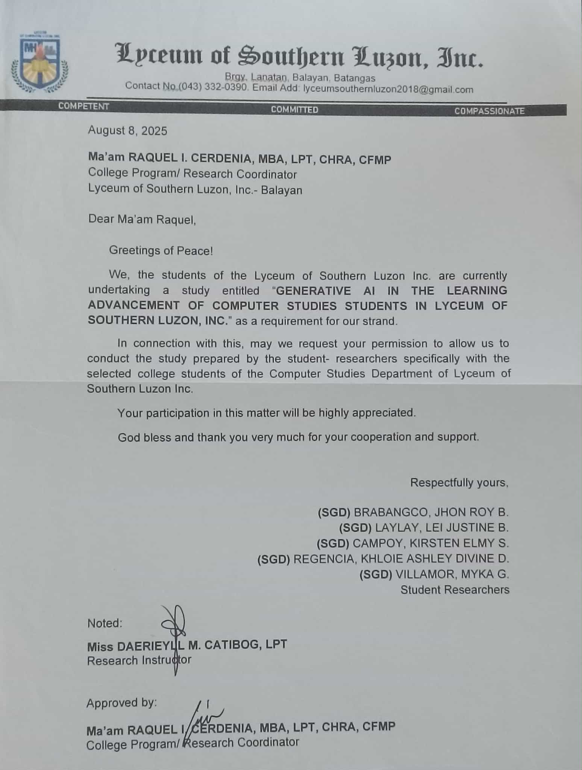
REQUEST LETTER

INTERVIEW QUESTIONS
1. How do Computer Studies students find AI-generated educational materials useful in your studies?

- What AI-generated educational materials and tools do you use in your computer-related studies? (EDUCAUSE, 2025)
________________________________________________________________________________________________________________________________________________________________________________________________

- In what way do you feel that using AI-generated content has helped you become more confident in your understanding of complex topics? (Guettala, 2023)
_______________________________________________________________________________________________________________________________
3. How do you use AI generated videos in your studies? (Leiker, 2023)
________________________________________________________________________________________________________________________________
4. How do you use AI generated audios or educational podcasts for your studies?
(Do, 2024)
________________________________________________________________________________________________________________________________

- How do you use AI generated images in your studies? (Berg, 2024)
________________________________________________________________________________________________________________________________

2. What are the students’ experiences with generative AI in terms of adaptive personalize learning support in computer studies?

- In your experience, how have AI tools adapted to meet your individual study needs? (Johnston, 2023)
________________________________________________________________________________________________________________________________

- How has generative AI helped you understand complex computer studies topics at your own pace? (Nosta, 2025)
________________________________________________________________________________________________________________________________
- What are your thoughts on AI’s ability to provide feedback and suggestions to your inquiries? Does it help you improve in programming? How or why not? (Zhang et al., 2023)
________________________________________________________________________________________________________________________________How do you experience a more personalized learning when using AI compared to other traditional methods? (The Beetroot Team, 2025)
________________________________________________________________________________________________________________________________

3. In what ways do students use generative AI tools to interactively construct their knowledge in programming?

- Can you describe a time when an AI tool helped you understand and discover a programming concept more deeply? (Bassner, 2024)
________________________________________________________________________________________________________________________________

- In what ways do you use AI to test and experiment with different programming exercises? (Scholl & Kiesler, 2024)
________________________________________________________________________________________________________________________________

- When you don’t understand a programming error, how do you use AI to give you hints in fixing or understand it? (Pankiewicz & Baker, 2024)
_______________________________________________________________________________________________________________________________

4. How does the use of AI tools influence students' reflective transformation of AI's effectiveness in education?

- As an AI-user, what do you think are the benefits of using GenAI tools in a classroom setting? (ResumeGemini Career Experts, 2024)
________________________________________________________________________________________________________________________________
- As an AI-user, what do you think are the harms or negative effects of using GenAI tools in your studies? (Bastani et al., 2024)
________________________________________________________________________________________________________________________________
- What are the concerns or guilt that you experience in using AI in education? Do these concerns change the way you use AI? (Chan, 2024)
________________________________________________________________________________________________________________________________

NARRATIVE REPORT
The development of this paper lasted around 1 school year, wherein it has undergone many revisions based on our research instructor’s and panelists' advice. It was first proposed and accepted on March 5, 2025, and completed around early October, and faced its final defense on October 20, 2025. During its first revisions, the researchers changed its theoretical framework and focused on computer studies students as the research’s main participants. The main hurdle in developing the paper was the Review of Related Literature and Studies, where the researchers were required to redo the whole segment when they replaced their theoretical framework. This was done around the end of summer vacation and the entirety of June.
Then, during late July, the researchers started the construction and verification of interview questionnaires. This was done with the help of Ma’am Raquel I. Cerdenia MBA, LPT, CHRA, CFMP, and Ma’am Daerieyll M. Catibog, LPT. After verification, they had to request consent to interview the college department, specifically the Bachelor of Science in Information Systems (BSIS) students, which Ma’am Raquel I. Cerdenia MBA, LPT, CHRA, CFMP allowed through signing a consent paper that the researchers gave on August 8, 2025. After that ordeal, the researchers conducted and passed on printed interview questions to the grade 11 Information and Communications Technology (ICT) students and BSIS year 1-4 students. The collection process took around a week to a month, and this was due to the schedule differences of the researchers and BSIS students. Because of this, they had to resort to online questionnaires, through Google Forms, where they conducted around 6 written interviews. After all answers were collected, it underwent thematic data analysis, where the researchers found similar themes and tallied the most common themes. This process was done around the span of August to September 2025.
Finally, for the last steps, the researchers undergone a final defense wherein they successfully defended the paper. However, the panelist suggested areas to improve and revise, primarily the output. Before creating the final hardcopy of the paper, it has been revised and have been rechecked by our research instructor, Ma’am Daerieyll M. Catibog.

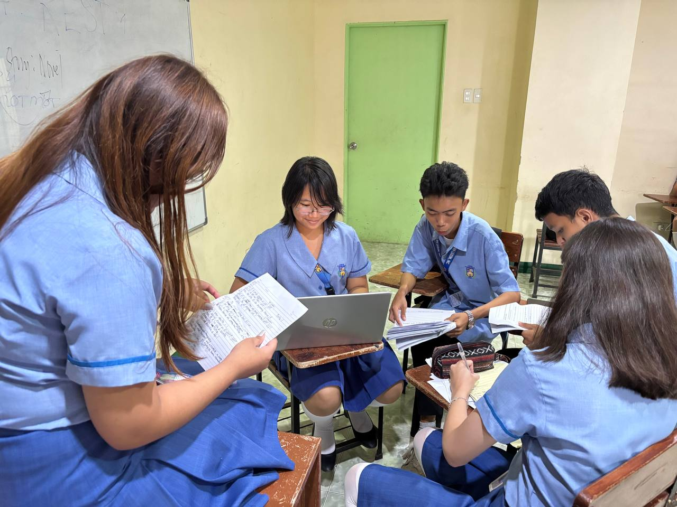
DOCUMENTATION
-+

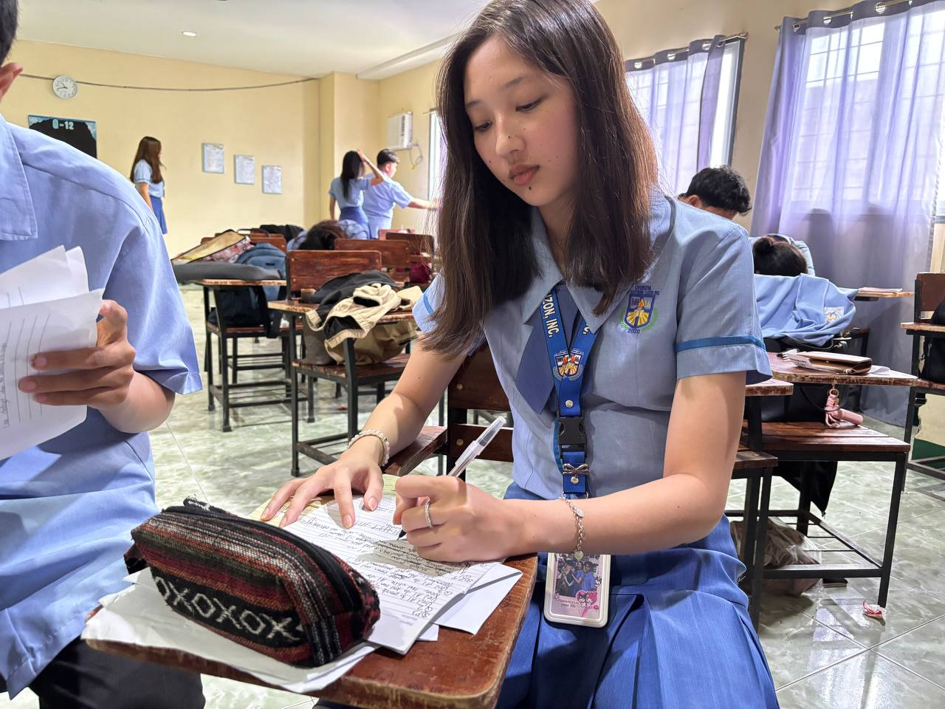

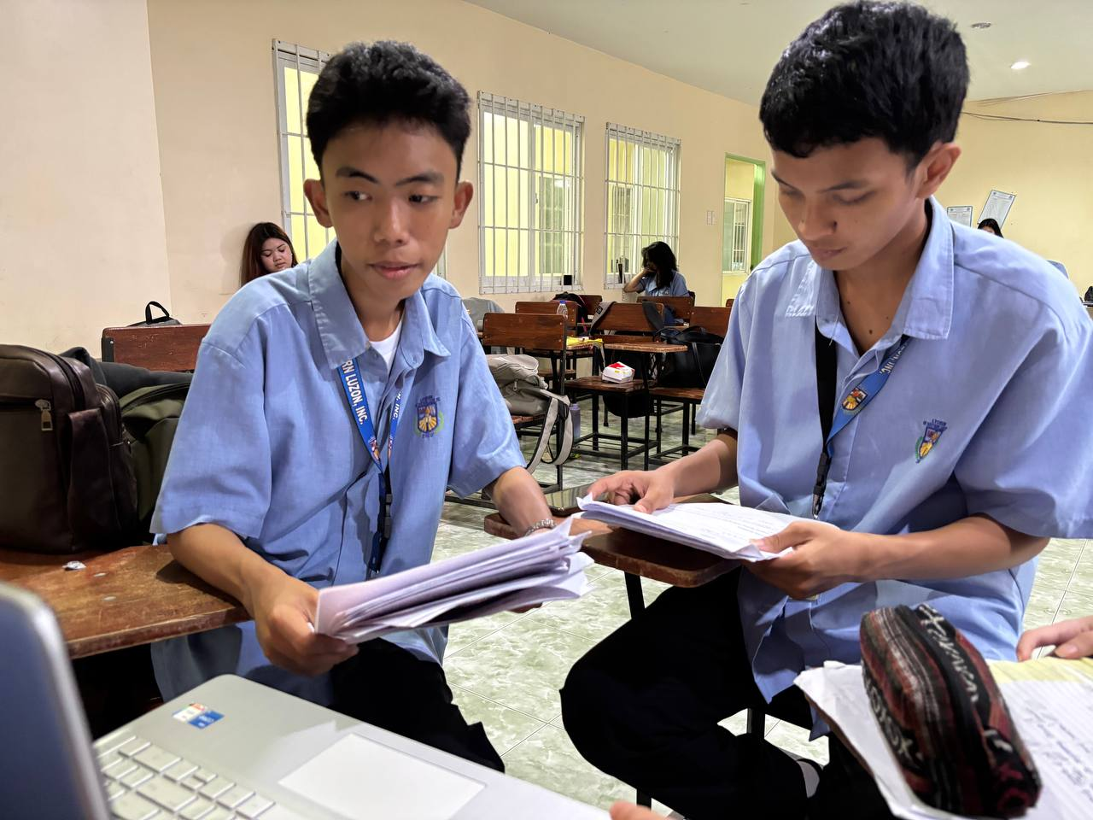


CURRICULUM VITAE

JHON ROY B. BRABANGCO
Balibago, Calatagan, Batangas
Mobile Number: 09974918346
Email Address: brabangcojhonroy@gmail.com
OBJECTIVES
To learn, gain knowledge, develop skills, and prepare for future academic or career goals.
SKILLS
• Critical thinking and problem solving
• Teamwork and collaboration
• Professionalism and strong work ethic
• Adaptability
• Oral and written communications skills
PERSONAL DATA
NAME : Brabangco, Jhon Roy B.
AGE : 16
BIRTH DATE : October 27, 2008
BIRTH PLACE : Taal, Batangas
ADDRESS : Balibago, Calatagan, Batangas
MOTHER’S NAME : Jenelyn Brabangco
FATHER’S NAME : Roy Brabangco
CIVIL STATUS : Single
CITIZENSHIP : Filipino
RELIGION : Catholic
EDUCATIONAL BACKGROUND
PRIMARY : Balibago Elementary school
S.Y. 2014 -2019
SECONDARY : Matabungkay National High School
S.Y. 2019-2023
Lyceum of Southern Luzon, Inc.
S.Y. 2024-2026



LEI JUSTINE B LAYLAY
Subd. Milflores, Balayan, Batangas
Mobile Number: 09657662638
Email Address: Leijustine39@gmail.com
OBJECTIVES
To obtain a challenging position in a reputable organization where I can apply my skills and knowledge, contribute to team success, and continue to grow both personally and professionally. I aim to utilize my strong communication skills, hardworking attitude, and dedication to help achieve the company’s goals.
SKILLS
• Hardworking and reliable team member
• Excellent oral and written communication skills
• Critical thinking and problem-solving abilities
• Teamwork and collaboration
• Professionalism and strong work ethic
PERSONAL DATA
NAME : Laylay, Lei Justine B.
AGE : 17
BIRTH DATE : December 2, 2007
BIRTH PLACE : Naujan, Oriental Mindoro
ADDRESS : Milflores Villas, Balayan, Batangas
MOTHER’S NAME : Ellen D. Brucal
FATHER’S NAME : Jhunie F. Laylay
CIVIL STATUS : Single
CITIZENSHIP : Filipino
RELIGION : Roman Catholic
EDUCATIONAL BACKGROUND
PRIMARY : Caloocan Elementary School
S.Y. 2014-2019
SECONDARY : Balayan national high-school
S.Y. 2019-2024
Lyceum of Southern Luzon, Inc.
S.Y. 2024-2026



KIRSTEN ELMY S. CAMPOY
Brgy. Caloocan, Balayan, Batangas
Mobile Number: 0960-871-5937
Email Address: kirstencampoy@gmail.com
OBJECTIVES
To evolve my analytical and leadership skills through effective communication and evaluation of my work. To leave a mark in the world of academics and add more to the river of knowledge and research.
SKILLS
• Computer Skills
• Perseverance
• Critical Thinking
• Multi-tasking
PERSONAL DATA
NAME : Campoy, Kirsten Elmy S.
AGE : 17
BIRTH DATE : June 28, 2008
BIRTH PLACE : Rome, Italy
ADDRESS : Brgy. Caloocan, Balayan, Batangas
MOTHER’S NAME : Campoy, Elisa S.
FATHER’S NAME : Campoy, Timy V.
CIVIL STATUS : Single
CITIZENSHIP : Filipino
RELIGION : Jehovah’s Witnesses
EDUCATIONAL BACKGROUND
PRIMARY : Balayan Kiddie Learning Center
S.Y. 2014-2019
SECONDARY : Lyceum of Southern Luzon, Inc.
S.Y. 2020-2026



KHLOIE ASHLEY DIVINE REGENCIA
Cayponce, Balayan, Batangas
Mobile Number: 09952134900
Email Address: yulevilldelpilar@gmail.com
OBJECTIVES
To gain knowledge and develop skills that will help me succeed in my life. And to build strong communication, teamwork, and problem solving skills through classroom and extracurricular activities.
SKILLS
• Communication skills (Oral and Written)
• Critical and Creative thinking
• Time management
• Teamwork and collaboration
PERSONAL DATA
NAME : Regencia, Khloie Ashley Divine D.
AGE : 17
BIRTH DATE : June 10, 2008
BIRTH PLACE : Marikina
ADDRESS : Cayponce, Balayan, Batangas
MOTHER’S NAME : Yulevill G. Del Pilar
FATHER’S NAME : Ferdie V. Regencia
CIVIL STATUS : Single
CITIZENSHIP : Filipino
RELIGION : Catholic
EDUCATIONAL BACKGROUND
PRIMARY : Balayan East Central School
S.Y. 2014-2019
SECONDARY : Balayan National High School
S.Y. 2019-2024
Lyceum of Southern Luzon, Inc.
S.Y. 2024-2026



MYKA G. VILLAMOR
Malibu, Tuy, Batangas
Mobile Number: 09474068684
Email Address: mykavillamor15@gmail.com
OBJECTIVES
To obtain an opportunity that allows me to apply and develop my knowledge and skills as a student. I aim to gain valuable learning experiences, enhance my competencies, and contribute positively to the growth and success of the institution or organization I will be part of.
SKILLS
• Adaptability and willingness to learn new concepts
• Effective communication and interpersonal skills
• Time management and organizational abilities
• Oral and written communications skills.
• Leadership
PERSONAL DATA
NAME : Villamor, Myka G.
AGE : 17
BIRTH DATE : June 15, 2008
BIRTH PLACE : Parañque City
ADDRESS : Malibu, Tuy, Batangas
MOTHER’S NAME : Mirasol G. Villamor
FATHER’S NAME : Michael D. Villamor
CIVIL STATUS : Single
CITIZENSHIP : Filipino
RELIGION : Catholic
EDUCATIONAL BACKGROUND
PRIMARY : Baclaran Elementary School Central
S.Y. 2012-2019
SECONDARY : Maria Paz Fronda National High School
S.Y. 2019- 2024
Lyceum of Southern Luzon, Inc.
S.Y. 2024-2026

